**“AUCTION WORLD”**

**“USER MANNUAL”**

**“GROUP MEMBERS”**

**NAME:**

|  |  |
| --- | --- |
| Student1307138 | MUHAMMAD OSAMA ALAM |
| Student1307145 | MUHAMMAD FARHAN |
| Student1309739 | ABDULRAHIM |
| Student1308257 | HASEEB JAN |

**BATCH CODE:** 2103F1

**FACULTY:** MISS TOOBA KHAWAR

**COORDINATOR:** MISS SIDRA SALEEM



1. INTRODUCTION:

PROBLEM STATEMENT:

AuctionsTable is an organization selling valuable items and goods through auctions. They have a vast experience of organizing auctions for past 25 years. Now with the client base expanding, they want to provide e-services for auctions. Hence they want a website to be created with proper auction features

REQUIREMENTS AND SPECIFICATION:

The Website is to be created based on the following requirements.

1. The home page must be designed with beautiful color combination with all the required links defined properly. Also all the section of the webpage must be in used to avoid the blank space.
2. Home page should display all available items available for auction as a slide show.
3. Menu should provide links to various auctions. Categorization of items should be done viz. Furniture, Paintings etc.
4. On moving to any particular category, it should list various items available for auction.
5. Clicking on any item should display the details of item along with the base price of the item.
6. Menu should also provide link to completed auctions displaying the final price of product/item.
7. About us, Contact Us, Disclaimer must be included.



1. (Creating an account facility can also be added.
2. Dummy procedure for placing bid to be added.
3. Sitemap must be added.
4. Navigation of the project must be made smooth.

**2. DISCRIPTION:**

The website is dividedinto 4 different pages:

* Home
* Our Categories
* About Us
* Contact Us

Each page contains the navigation bar that has hyperlinks to different pages. At the bottom of every page there is footer that contains basic details.

HOME:It shows the overview of all pages in the website.These pages are explained briefly.it is to serve as a teaser and trustworthy guide towards the pages that have the necessary information. A **homepage** isn't a library. It's a guide towards pages that contain necessary information.

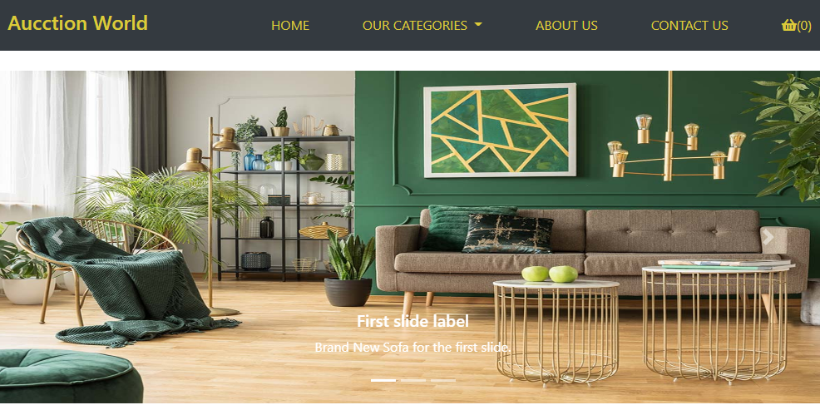

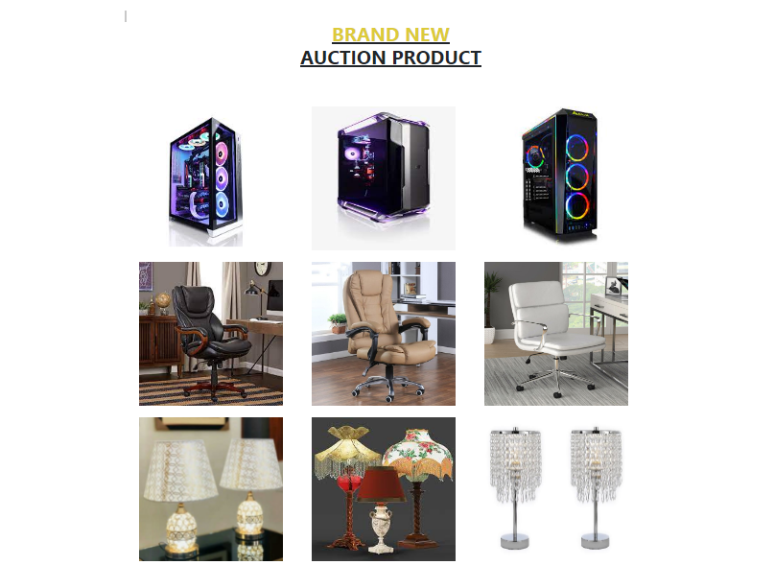

CATEGORIES:IT CONTAINS A WIDE RANGE OF DIFFERENT CATEGORIES OF PRODUCTS.THERE ARE DIFFERENT COLLECTIONS OF BRANDS WITH DIFFERENT AUCCTION SCHEMES.

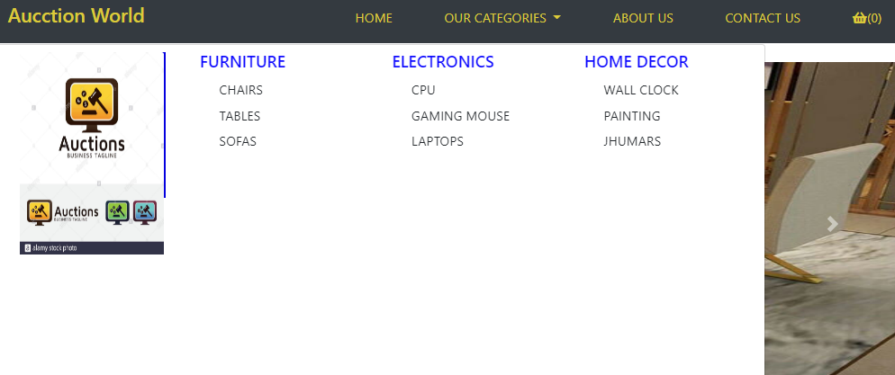

About us:it contains information about the founder and our Auctions Projects.

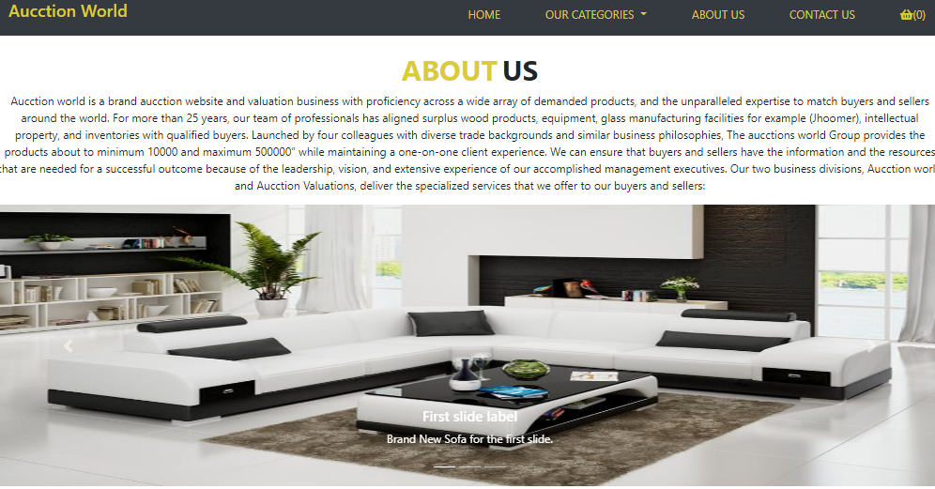

Contact us:User can give feedback and make query on this page. User can contact us at the given number and can also visit the shop. Location is provided.

